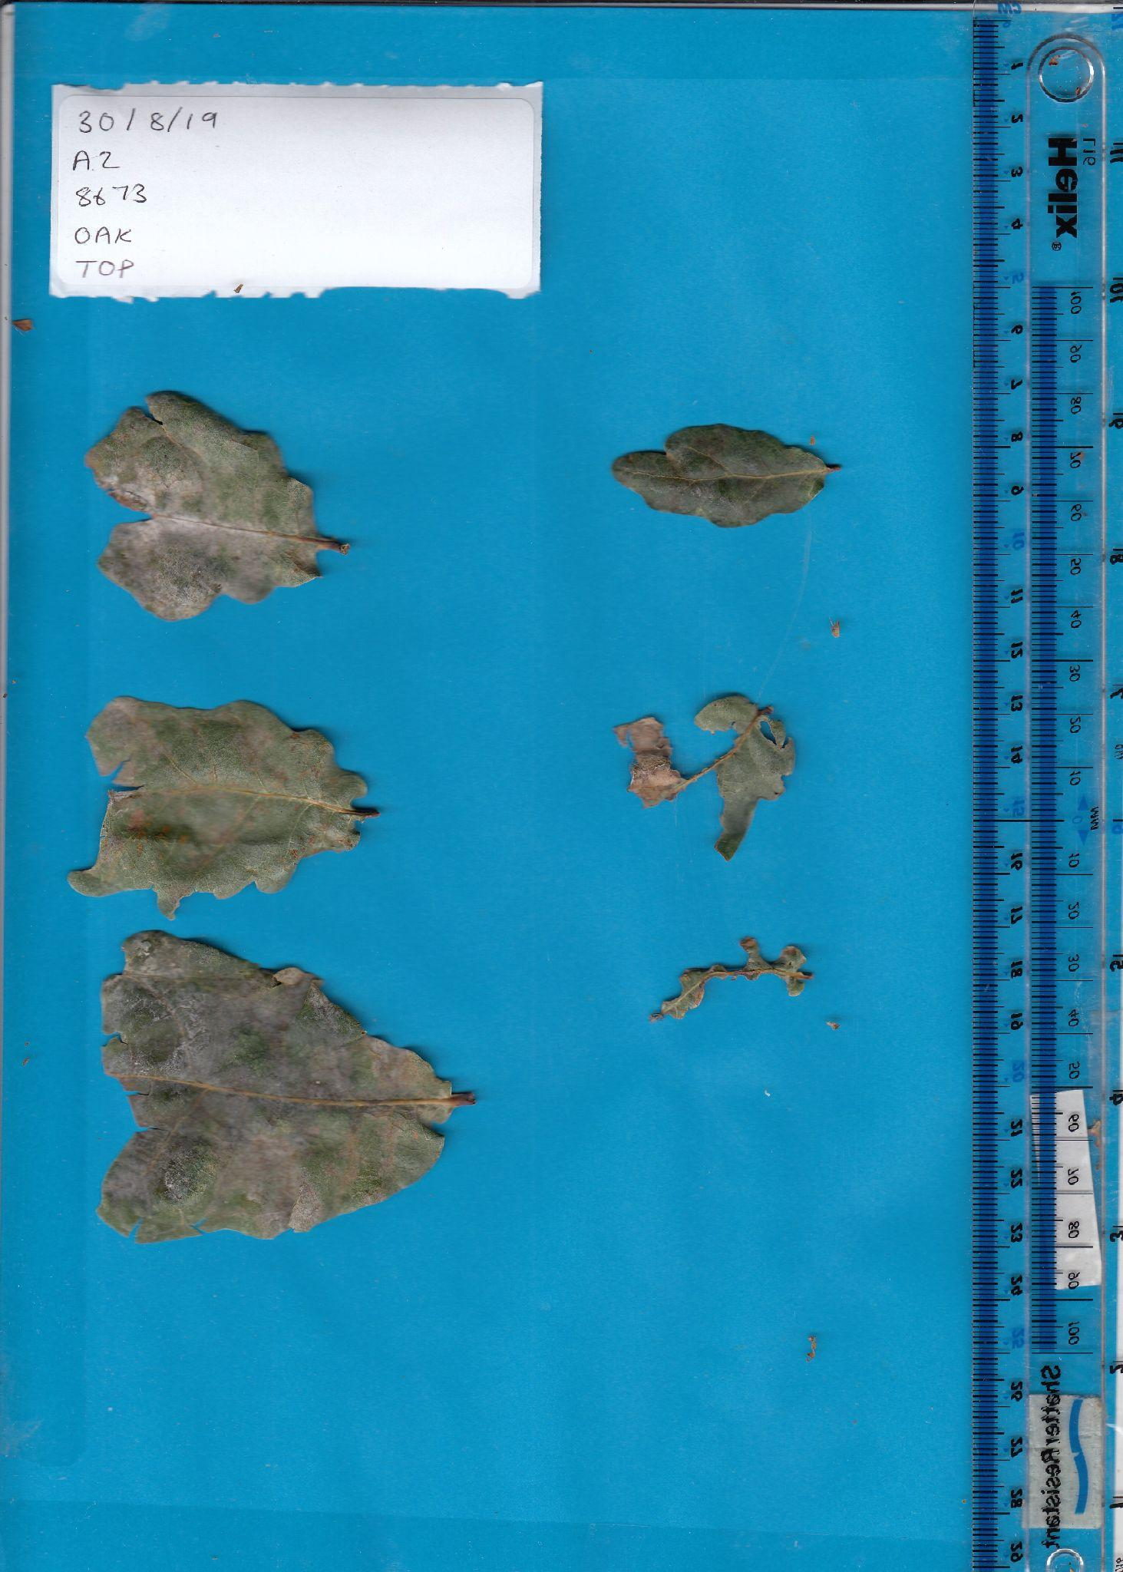

Example Image: Severely Infected Oak Leaf with Powdery Mildew- PM % Score: 59.94337892

